SIMATS ENGINEERING (SAVEETHA SCHOOL OF ENGINEERING)
Department of Artificial Intelligence and Data Science
ASSESSMENT TOOL 1 – Pattern Recognition and Text Processing

Course Code: | DSA03 | Course Title: | Natural Language Processing
CO Assessed: | CO1 – Imitation (L1) | Assessment: | Assessment Tool 1 – Pattern Recognition and Text Processing
Weightage: | 40% of CIA
CO5 Statement: | Analyse regular expression patterns. (BL-3)
Student Name: | I. Leela Sravan Kumar | Reg. No.: | 192425272
Section / Batch: | 2024 AIML | Date: | 11-07-2026

Code of Conduct
I I. Leela Sravan Kumar (192425272) (Name / Reg No) certify that this submission is my original work and that I have adhered to the guidelines specified for this assessment. I understand that any violation of academic integrity rules will result in disciplinary action.
Signature of the Student: I. Leela Sravan Kumar

Instructions
- Show all intermediate steps, calculations, state transitions, and reasoning wherever applicable.
- Use only the Python re (Regular Expressions) module to solve the given problems.
- Clearly mention the Regular Expression (Regex) pattern used before writing the corresponding Python program.
- Display the required output for each question, including extracted values, validation results, counts, and positions wherever applicable.
- Duration: 30 minutes.

Section / Topic | Focus | Q Nos
Regular Expression Pattern Generation | Pattern Matching Information Extraction | 1
Search for a String | Keyword Search and Text Analysis | 2
Split the documentation into sentences and words | Text Tokenization and Sentence Segmentation | 3
Email and Strong Password Validation | Data Validation and Format Verification | 4
Compile Once, Validate Many | Pattern Reusability and Performance Optimization | 5

Annexure A – Pattern Recognition and Text Processing

Section 1: Regular Expression Pattern Generation
Student Details:
Name: John Doe
Email: john.doe123@gmail.com
Mobile: +91-9876543210
Password: P@ssw0rd123
Date of Birth: 15/08/2004
Register Number: 23AIML1056
Department: Artificial Intelligence and Machine Learning
For the given student details formulate Regex patterns for the following:
Email ID
Mobile Number
Strong Password
Date of Birth (DD/MM/YYYY)
Register Number

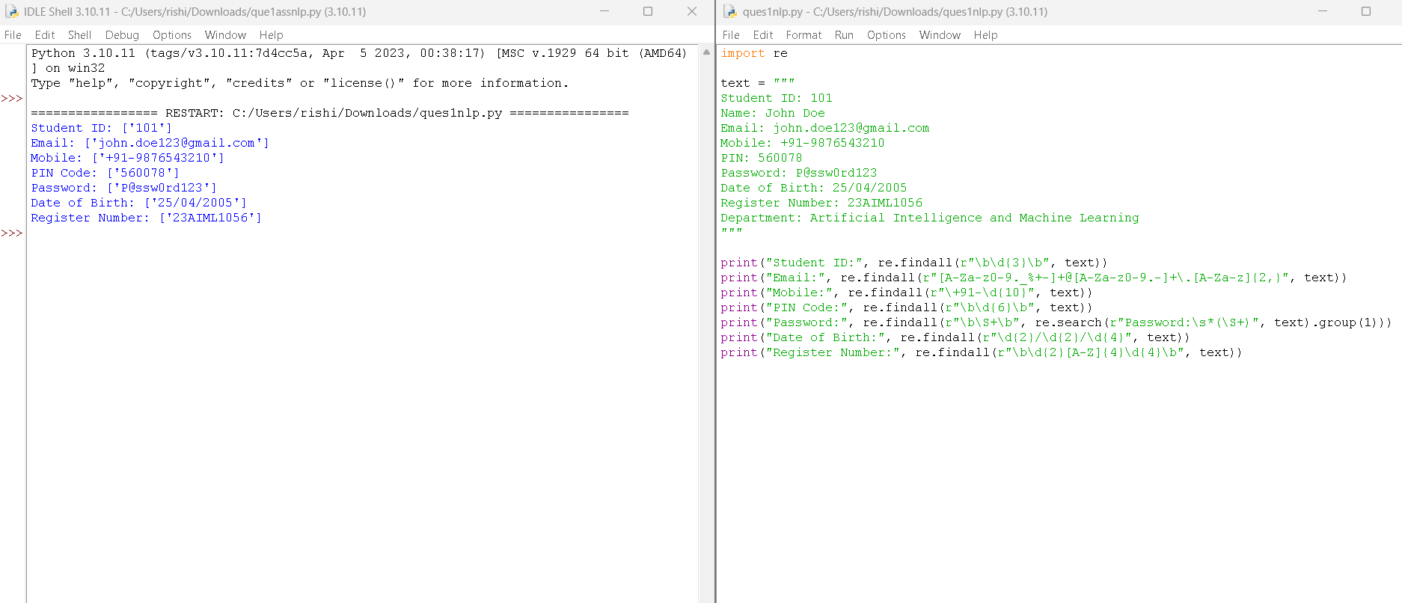
Section 2: Search for a String
Artificial Intelligence (AI) is transforming industries across the world. AI is used in healthcare to assist doctors in diagnosis, in banking to detect fraud, and in education to provide personalized learning experiences. Many companies invest heavily in AI research because AI improves efficiency and enables intelligent decision-making. As AI continues to evolve, professionals with AI skills are in high demand.
Write a Python program using the re module to perform the following operations for the word "AI":
- Find the first occurrence of the word "AI" using re.search().
- Display the starting position of the first occurrence.
- Display the ending position of the first occurrence.
- Display the total number of times the word "AI" appears in the passage.
- Print an appropriate message if the word is not found.
- 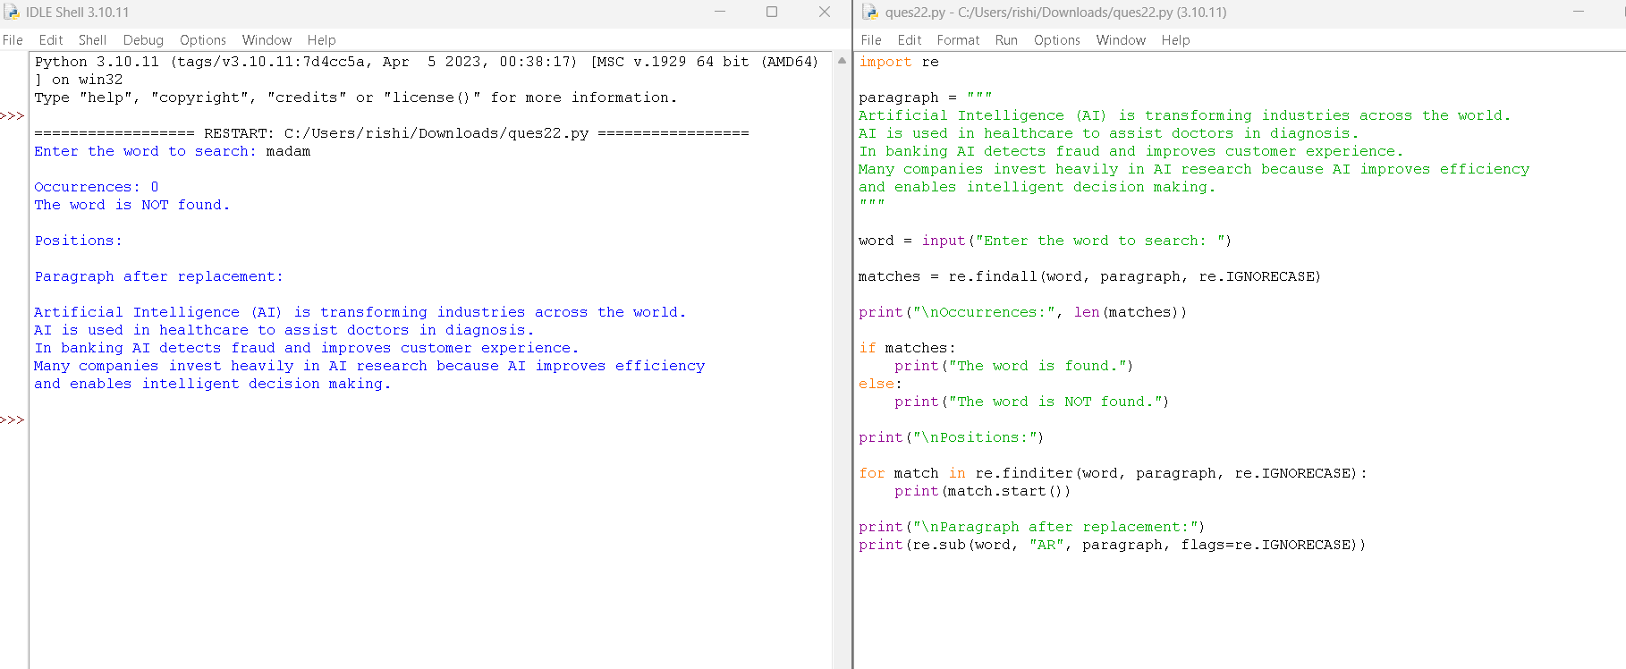
Section 3: Split the documentation into sentences and words
Refer the previous passage and Write a Python program using the re.split() method to perform the following operations:
- Split the passage into sentences using appropriate punctuation (., ?, !) as delimiters.
- Count and display the total number of sentences.
- Split the passage into words by considering one or more whitespace characters as delimiters.
- Count and display the total number of words.
- Display the list of extracted sentences and words.
- 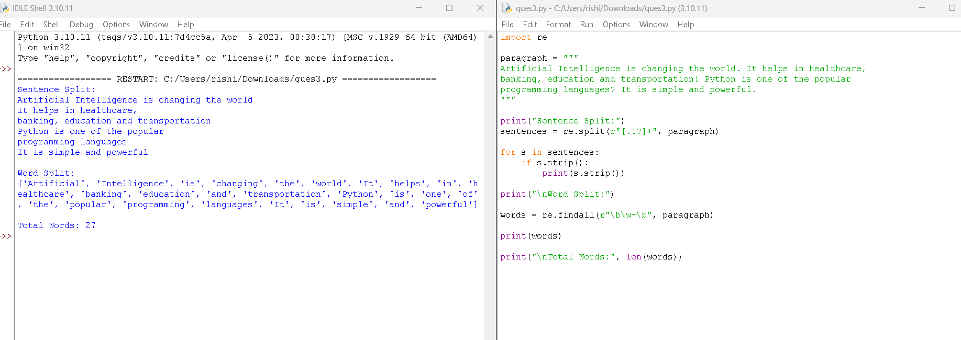
Section 4: Email and Strong Password Validation
A website requires users to register by providing an Email ID and a Strong Password. Write a Python program using the re module to validate the following inputs.
Validation Criteria:
Email ID
- Must begin with one or more letters or digits.
- May contain ., _, %, +, or - before the @ symbol.
- Must contain a valid domain name.
- Must end with a valid domain extension such as .com, .org, .edu, or .in.
Strong Password
- Must contain at least 8 characters.
- Must contain at least one uppercase letter.
- Must contain at least one lowercase letter.
- Must contain at least one digit.
- Must contain at least one special character from @, #, $, %, &, !, or *.
- Must not contain any whitespace characters.
- 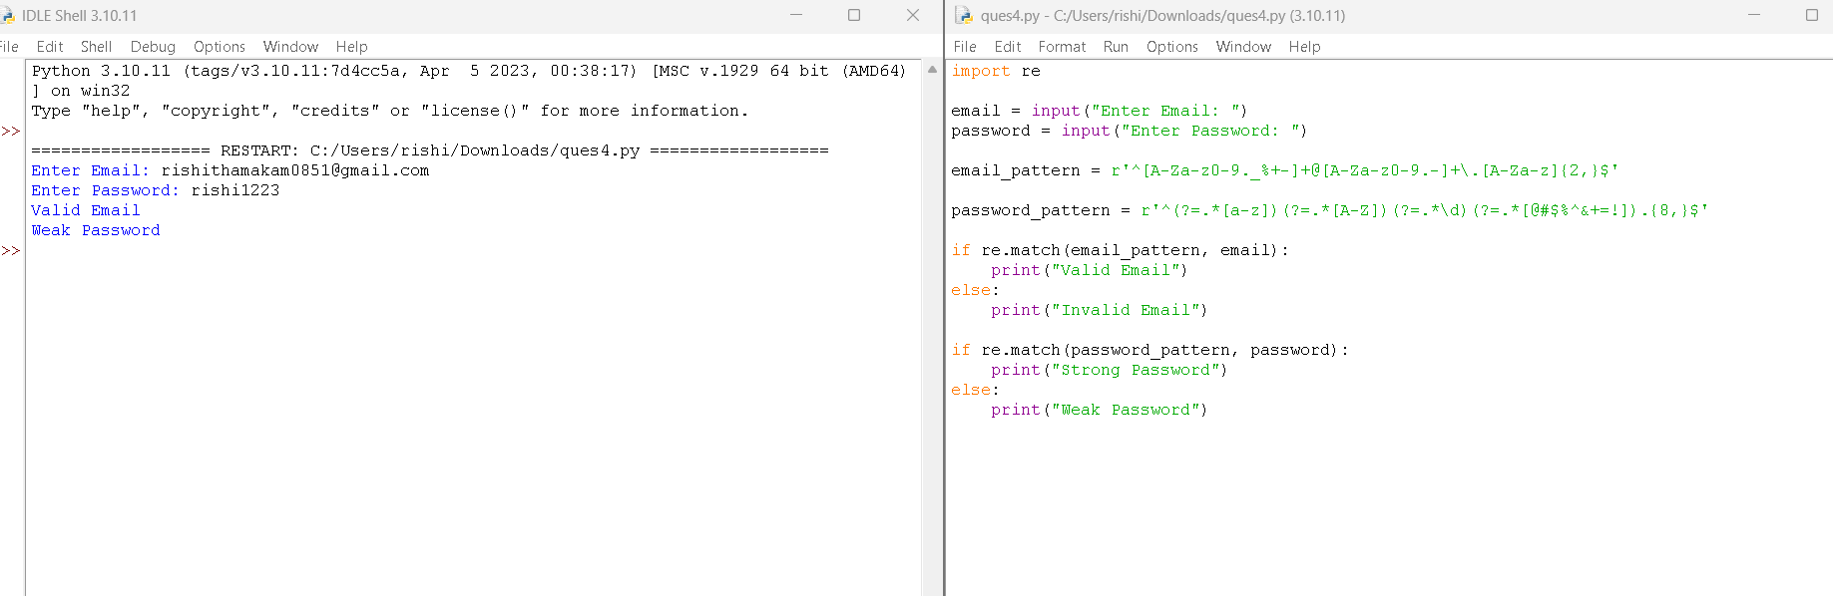
Section 5: Compile Once, Validate Many
A company receives 1,000 email IDs from its customers and needs to validate each one efficiently. Instead of compiling the same regular expression for every email, write a Python program using the re.compile() method to compile the pattern once and reuse it to validate all the email IDs.
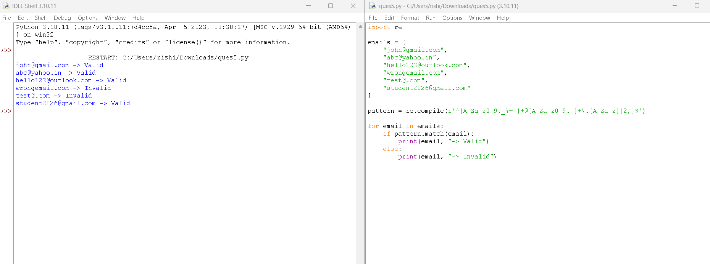

Rubrics for Calculation
Criteria | Weightage | Level 4 – Exemplary (5 Marks) | Level 3 – Proficient (4 Marks) | Level 2 – Developing (2–3 Marks) | Level 1 – Beginning (0–1 Mark)
Conceptual Understanding | 30 | Demonstrates clear and complete understanding of the concept | Good understanding with minor gaps | Basic understanding with some misconceptions | Poor or incorrect understanding
Accuracy of Answer | 25 | Completely correct answer with no errors | Mostly correct with minor errors | Partially correct with noticeable errors | Incorrect or irrelevant answer
Application of Knowledge | 20 | Correctly applies concepts to solve the question/problem | Applies concepts with minor mistakes | Limited or partially correct application | No or incorrect application
Completeness of Response | 15 | Covers all required parts of the question | Covers most parts with minor omissions | Covers only some parts | Incomplete or missing response
Clarity & Presentation | 10 | Clear, concise, and well-organized answer | Understandable with minor issues | Somewhat unclear or poorly structured | Difficult to understand

Q. No. / Criteria | Conceptual Understanding | Accuracy of Answer | Application of Knowledge | Completeness of Response | Clarity & Presentation | Sub. Total | Total %
1 | 3 | 3 | 3 | 3 | 3 | 15 | 75
2 | 3 | 3 | 3 | 3 | 3 | 15
3 | 3 | 3 | 3 | 3 | 3 | 15
4 | 3 | 3 | 3 | 3 | 3 | 15
5 | 3 | 3 | 3 | 3 | 3 | 15

Faculty In-charge | Course Coordinator | Program Director
Signature: _______________ | Signature: _______________ | Signature: _______________
Date: ___________________ | Date: ___________________ | Date: ___________________

